**Data Analytics for Finance: Website of Moritz Gort (3556173)**

1. Website URL: <https://moritzgort.netlify.app>

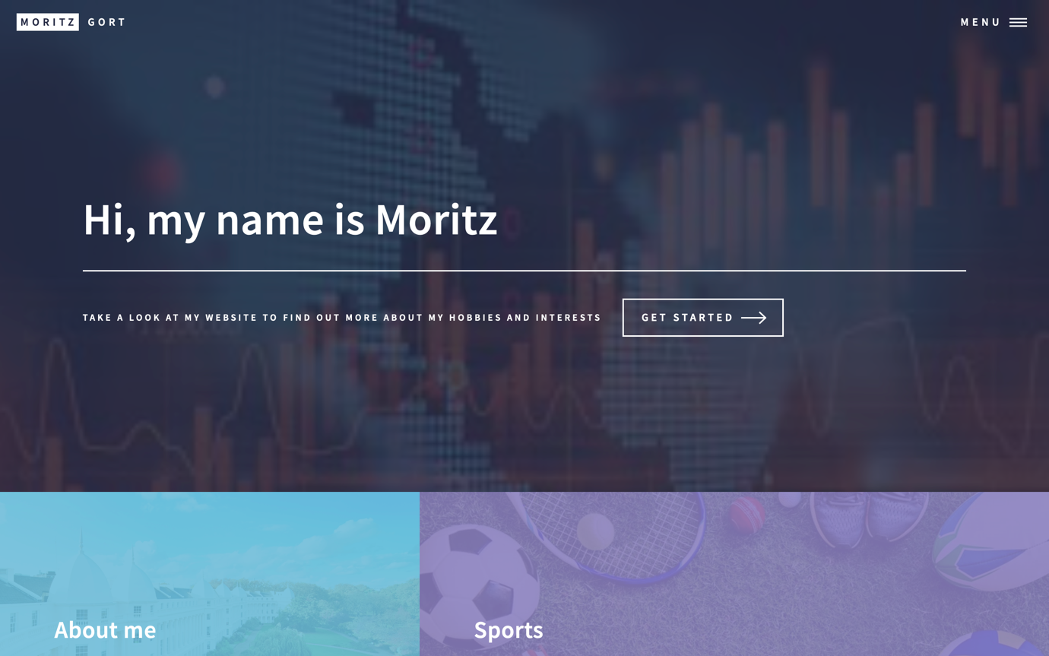

1. Github Repo: <https://github.com/moritzgort/my_website>

1. Netlify Account: <https://app.netlify.com/teams/moritzgort/builds>

